A

PROJECT REPORT

ON

**Banking Management System**

Towards partial fulfillment of the requirement in

**4th Semester BCA (2018-2019)**

**Submitted By:-**

Student1: Hardik Vaviya(170510101083)

Student2: Shubham Shukla(170510101092)

Student3: Kalp Zaveri(170510101086)

**Submitted To:-**



**Parul Institute Of Computer Application,**

**Parul University.**

Under The Guidance of

Assistant Professor,

Dharmendrasinh Rathod

ACKNOWLEDGEMENT

We would like to convey our heartfelt thanks to our Banking Management System Project for providing the good infrastructure and laboratory facility.

We are grateful and thankful to our beloved Principal Dr. Priya Swaminarayan for providing necessary facilities for achieving the goal.

We express our sincere thanks to Asst. Prof Dharmendrasinh Rathod, Guide for his valuable guidance ,interest and constant encouragement throughout the period of this project work.

We are thankful to all the teaching and non-teaching staff for allowing me to successfully carryout the project work.

Hardik Vaviya

Shubham Shukla

Kalp Zaveri

**Index**

|  |  |  |
| --- | --- | --- |
| **Sr No.** | **Details** | **Page No.** |
| 1 | Introduction to the system | 3 |
| 2 | Existing system | 4 |
| 3 | Drawbacks of Existing system | 5 |
| 4 | Functionalities of New system | 6 |
| 5 | Hardware/Software Details   1. System configuration 2. Tools and Technologies used | 7,8,9 |
| 6 | System Users | 10 |
| 7 | DFD   1. Context Level DFD 2. 1st Level DFD 3. 2nd Level DFD 4. 3rd Level DFD | 11,12,13  14,15 |
| 8 | ER Diagram | 16 |
| 9 | Activity Diagram | 16 |
| 10 | Use Case Diagram | 17 |
| 11 | Class Diagram | 18 |
| 12 | Data Dictionary | 19 |
| 13 | Form Design (Screenshots) | 21 |
| 14 | Future enhancement | 24 |
| 15 | Bibliography |  |

Introduction Of System

* The project titled “Banking Management System” is designed using Active Server Pages .NET with Microsoft Visual Studio.Net 2003 as front end and Microsoft SQL Server 2000 as back end which works in .Net framework version 1.1. The coding language used is C# .Net
* The project titled “Banking Management System ” is designed using Active Server Pages .NET and SQL Server 2000 which runs under .Net Frame Work 2003 in Microsoft Windows Operating System family.
* This system is used to manage the bank system which is used by bank. As we know that India has the largest number of customer in a banking sector.
* In this banking system there are 3 login places such as administration, customer and employee.

Existing system

* Our banking management system is work inside the computer system of bank.
* Our system have three type of user.1)Admin 2) Customer 3) Employee.
* With the admin control admin can create id and password for customer control and employee control and also view information about customer a/c and transaction.
* With the customer control they can 1)Create Account 2)Update Account 3) view reports etc…
* With the employee control employee can perform transaction, view reports, generate OTP, View transaction.

Drawbacks of Existing System

* Lack of security of data.
* Time consuming.
* Consumes large volume of paper work.
* Needs manual calculations.
* No direct role for the higher officials.
* Damage of machines due to lack of attention.

Functionality of new system

* Banking calculator.
* Online information about auction of properties.
* Loan Facility is available soon.
* Security Get improved as per new updates come.

Modules Description

The Modules description of Bank Account Management System project. These modules will

be developed in ASP.NET source code and MYSQL database.

1. Create New Account: A customer who having the account in the world can create a

Virtual account through this module. This module receives the customer profile details

and the bank account details with the proof of the ownership of the bank account.

2. Login: Virtual account holders can login in to the system using this module. Thus this

is the secured login page for the customers in the website.

3. Virtual Account: After the approval of new virtual account creation, the customer

Assigned a unique virtual account number to make the online money transactions. This

module views the details of the logged customer's virtual account.

4. Bank Accounts: A customer may have more than one bank account in various banks,

in this case, the customer prompted to decide which bank account should reflect in the

account debit or amount credit. For these operations customers can add their owned

bank accounts here and it will be approved by the administrations of the system.

5. Fund Transfer: This is the module to make fund transfer to the virtual bank account

holders or the usual bank account holders from the customer's specified bank

account.

6. Beneficiary: Beneficiary is a person who receives money. Here the customer can add

the beneficiaries to make fund transfer in the future.

7. Transactions: This module displays the transactions made by the customer in the

particular date with the transaction details.

8. Administrative Control: This module contains the administrative functions such as view all virtual account, transactions, approve bank accounts, approve virtual

accounts etc.

SOFTWARE REQIUREMNTS

The software used for the development of the project is:

OPERATING SYSTEM : Windows XP Professional

ENVIRONMENT : Visual Studio .NET 2003

.NET FRAMEWORK : Version 1.1

LANGUAGE : C#.NET, ASP.NET

BACKEND : SQL SERVER 2000

HARDWARE REQIUREMNTS

The hardware used for the development of the project is:

PROCESSOR : PENTIUM III 866 MHz

RAM : 1 GB or More

MONITOR : 15” COLOR

HARD DISK : 20 GB

CD DRIVE : LG 52X

KEYBOARD : STANDARD 102 KEYS

MOUSE : 3 BUTTONS

Tools and Technologies used

* Technologies we are going to use such as ASP.NET with C# as backend code.
* In the front we use basic HTML with CSS.
* Tools used such as Laptop.

System Users

1. Administrator :- The role of bank admin is to create id and password for customer control and employee control for website. admin can also view all transaction and all information of customer.

2. Employee :- The role of Employee control is to view reports of customer account and also done transaction according to need of customer and also generate OTP(one time password) for transaction.

3. Customer :- The role of Customer control is to create new customer account according to application form and also update account if needed and view reports of customer account and also can change password, view transaction report..

DFD

Context Level DFD Banking Management Systems

Employee

Customer

Admin

Login and Manage A/c Account summary/Report

Edit and Takes Reports Login & Account Details

Transaction Reports Login and Create Transaction

**Customer**

**Management**

**Employees**

**Management**

**Generate Fixed**

**Deposit Reports**

Report

**Generate**

**Accounts Report**

**Generate**

**Employee Report**

**Fixed Deposit**

**Management**

**Accounts**

**Management**

**Generate**

**Customer Report**

**Saving Account**

**Management**

**Current**

**Management**

**Generate**

**Current Account Report**

**Check**

**Saving Account Details**

1st Level DFD Banking Management System

2nd Level DFD Admin Banking Management System

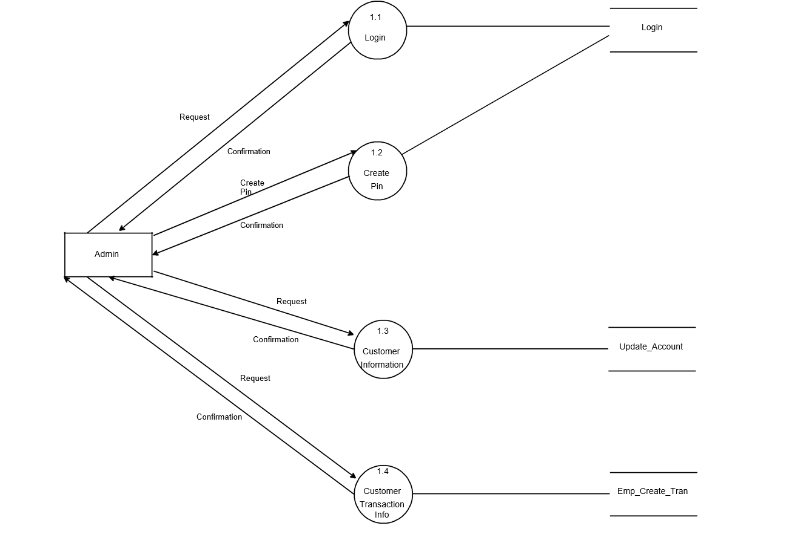

2nd Level DFD Customer Banking Management System

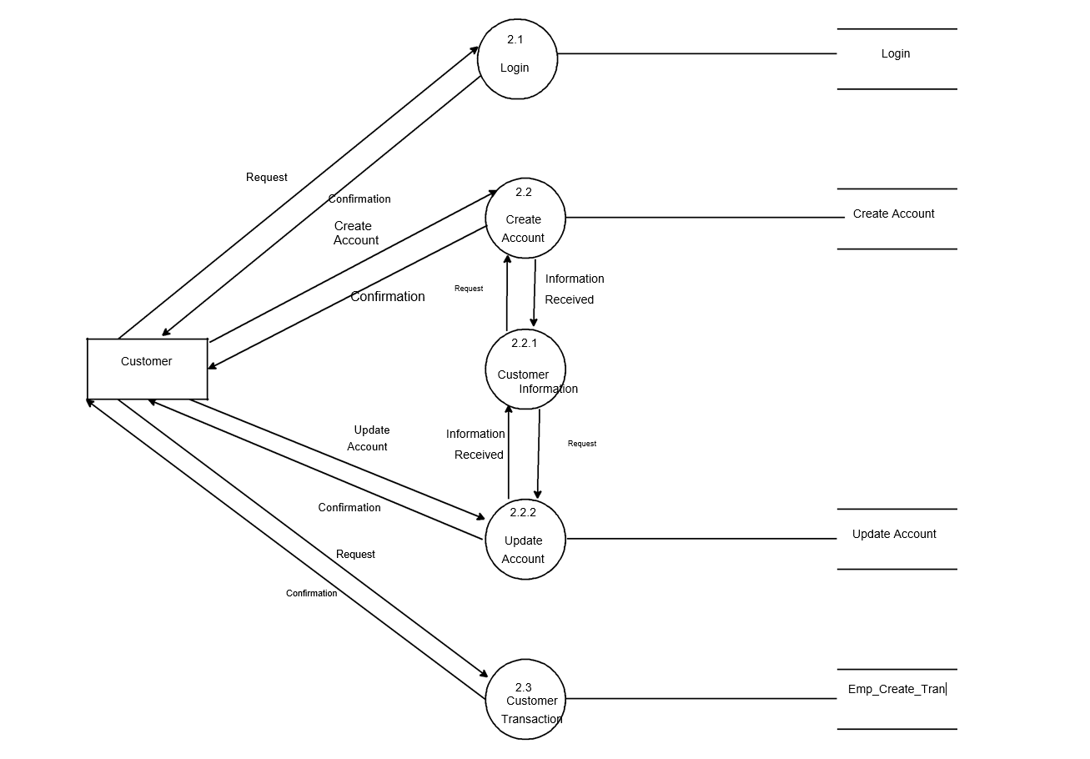

2nd Level DFD Employee Banking Management System

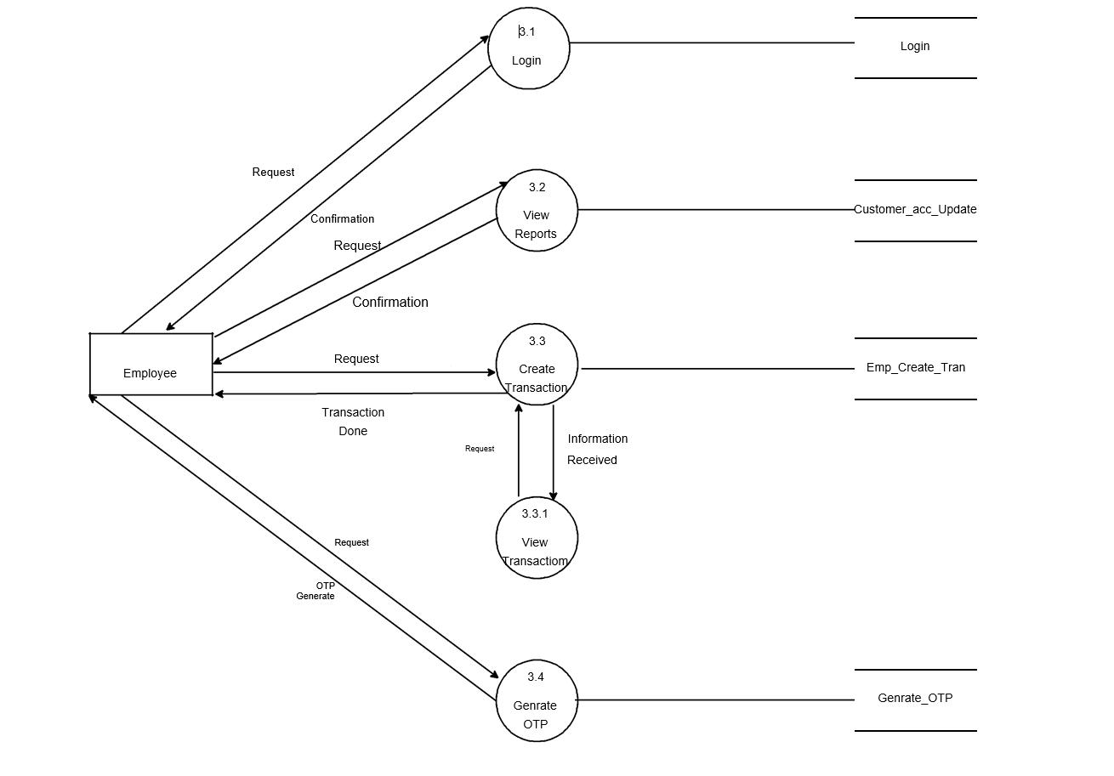

E-R Diagram for Banking Management System

**Account**

Borrow

**Customer**

**Loan**

Loan

Branch

Admin

**Branch**

**Admin Info**

**Transaction**

Customer A/c Info

Use Case Diagram

Customer

Employee

Admin

Data Dictionary

Branch Info

|  |  |  |
| --- | --- | --- |
| Fieldname | Type | Constraints |
| Branch no | Varchar(7) | Primary key |
| Branch name | Varchar(20) |  |

Deposit info

|  |  |  |
| --- | --- | --- |
| Field name | Type | Constraints |
| Account no | Int | References Account info(Account no) |
| Branch no | Varchar(20) |  |
| Depositor name | Varchar(20) |  |
| Account type | Varchar(20) |  |
| Deposit amount | Varchar(20) |  |
| Deposit Date | Date Time |  |

Login table

|  |  |  |
| --- | --- | --- |
| Fieldname | Datatype | Description |
| Username | Varchar(20) | Primary Key |
| User Password | Varchar(15) |  |

Withdrawal Table

|  |  |  |
| --- | --- | --- |
| Fieldname | Type | Constraints |
| Account number | Int | References A/c info(Account number) |
| Branch no | Varchar(7) |  |
| Withdrawal name | Varchar(15) |  |
| Account type | Varchar(15) |  |
| Withdrawal | Varchar(15) |  |

Form Design (Screenshots)

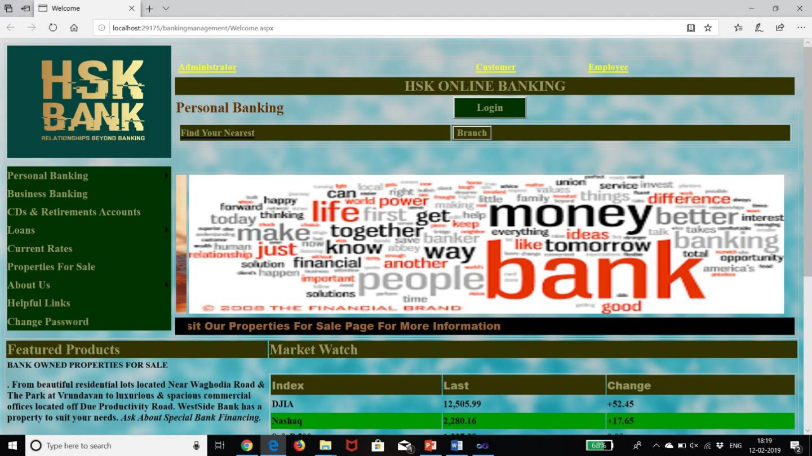

1.1 Main Page

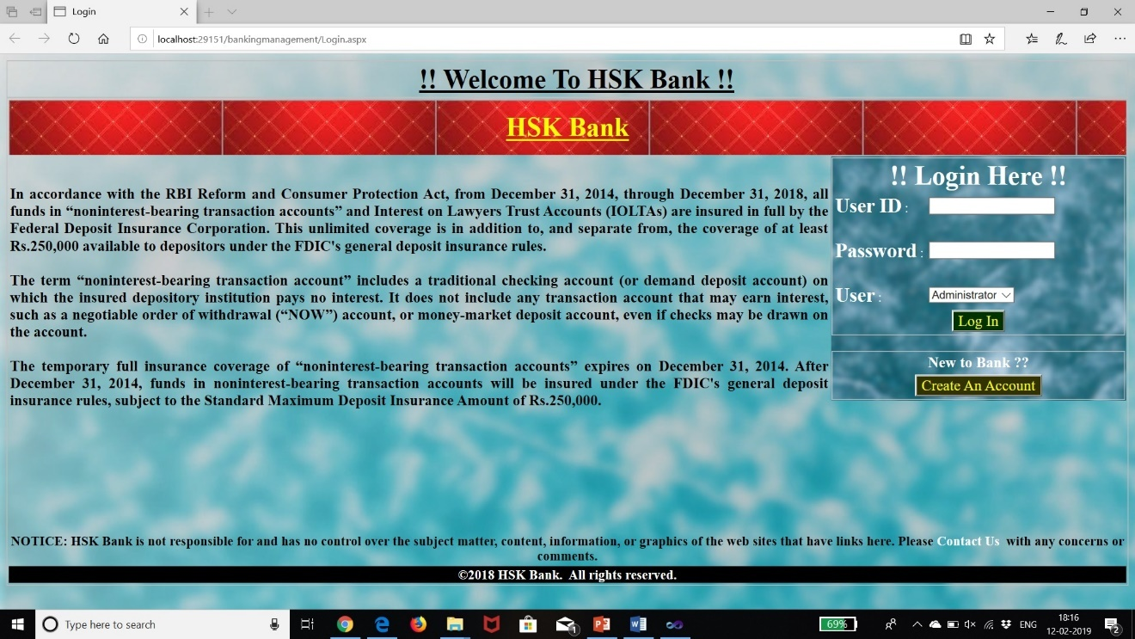

1.2 Login Page

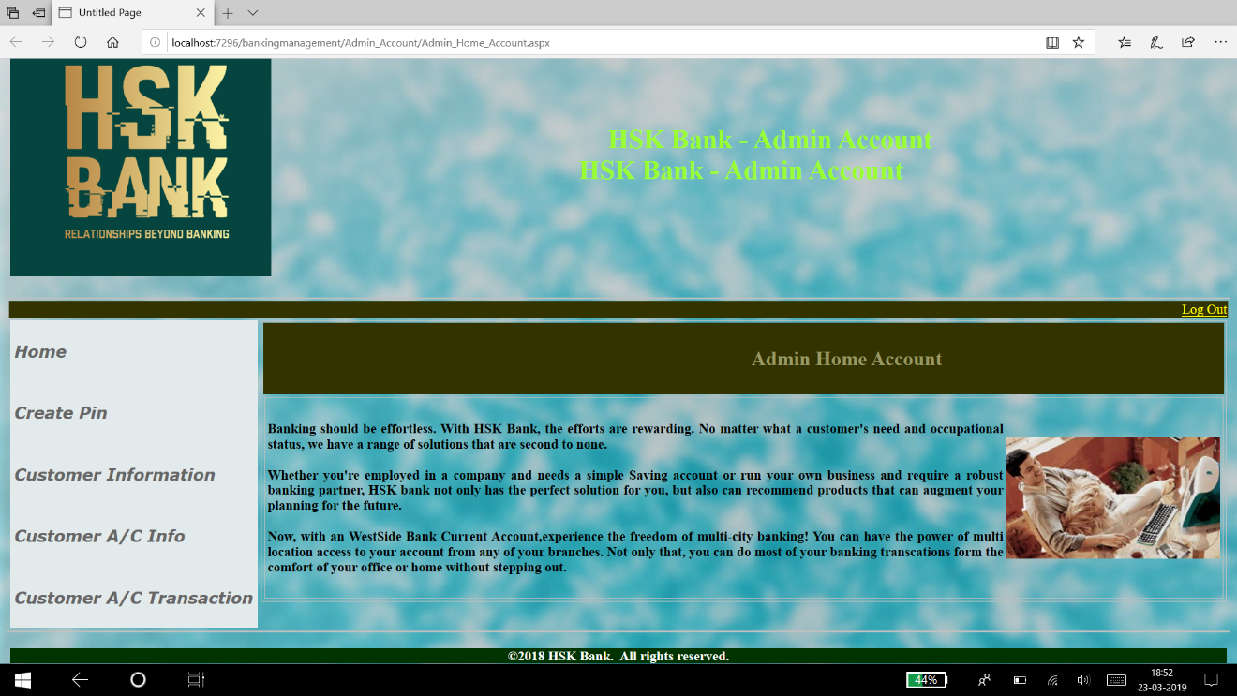

1.3 Admin Home Account

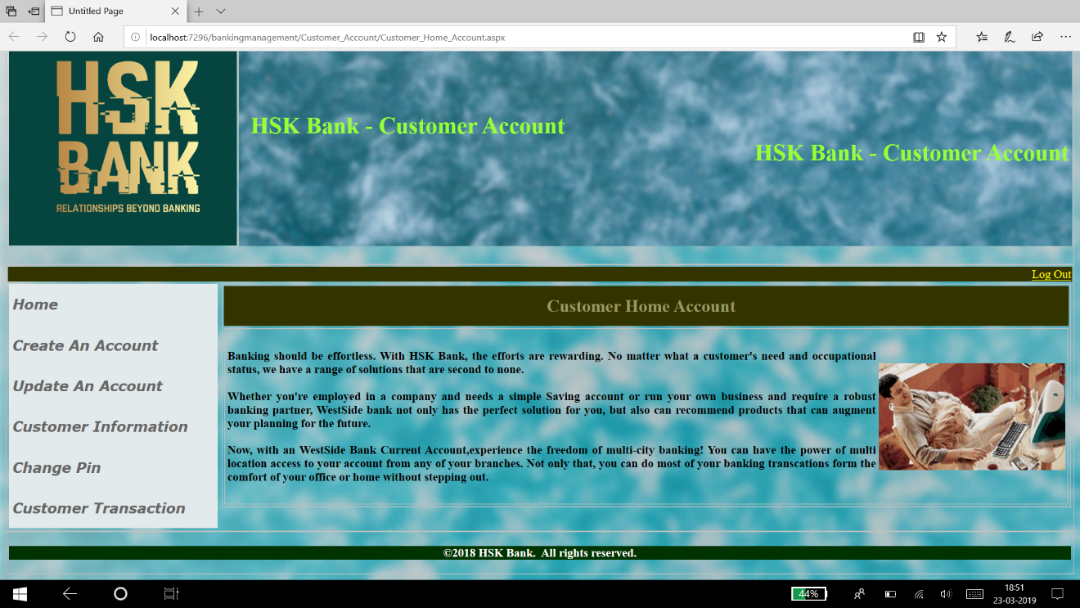

1.4 Customer Home Account

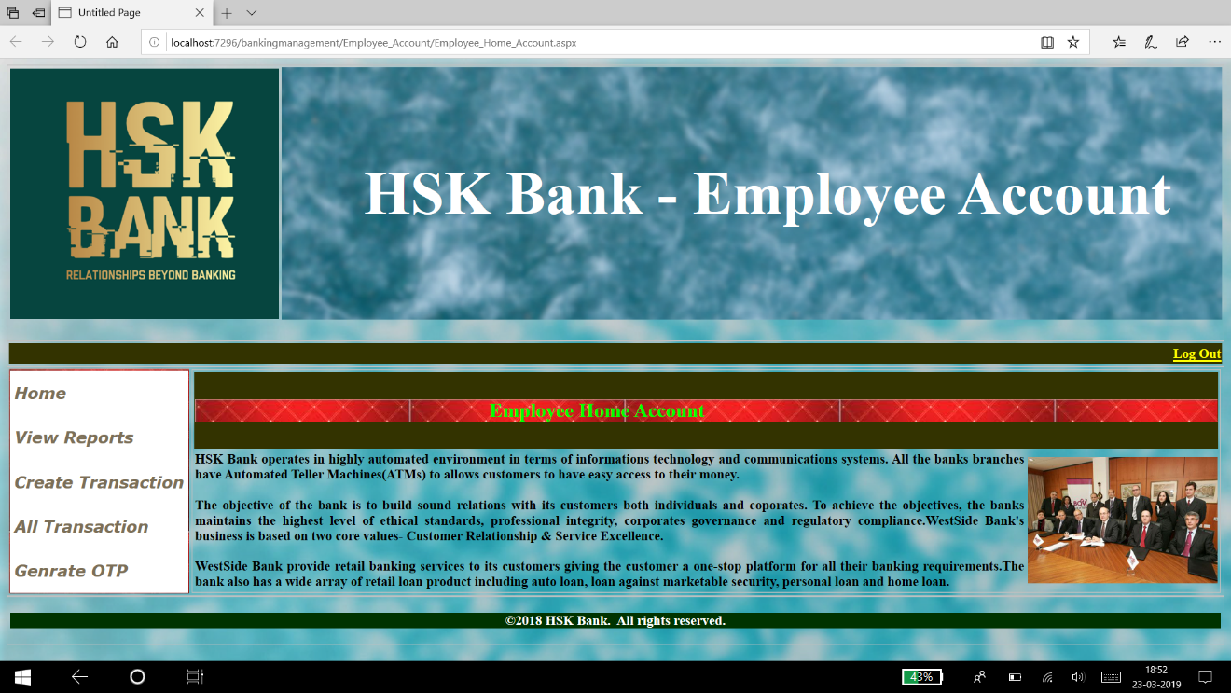

1.5 Employee Home Account

Future Enhancement

Current status of project: -This project has been completed but we can add more things like ATM, Online Transactions through Online Banking.

Remaining areas of concern: -This software project is complete and can be used to access records, can generate reports whenever necessary or needed.

Technical and managerial lessons learnt: - During the development of project we have learnt many lessons like the rules prevailing within an organization like: -

Proper defined structure.

Good chain of commands.

Work should be divided among each other.

Effective and efficient environment for working and development.

Future recommendations: -As we all know that the change is permanent, so according to change this project can be modified or manipulated according to needs.